SIMATS ENGINEERING
ASSESSMENT TOOL 3 – Assignment 2

COURSE NAME: STATISTICS WITH R PROGRAMMING COURSE CODE: ITA04
COURSE OUTCOME COVERED

CO3: Construct and manipulate data frames using reshaping, merging, and file I/O operations in R to prepare structured datasets for analysis. (BL3, BL5)

Assessment Tool Weightage: 20%

QUESTIONS: 5 Total Marks: 100

Question 1: Create a Loan Applicant Dataset
Formula: - $D=\{A_{1},…,A_{10}\}$
Each applicant is represented as:

$A_{i}=(ID,G,Age,MI,CS,LA,ES,EL,LS)$
Problem: Create a loan applicant dataset containing 10 applicants with attributes such as Applicant ID, Gender, Age, Monthly Income, Credit Score, Loan Amount, Employment Status, Existing Loan, and Loan Status.
Explanation: $D$ = Complete loan applicant dataset.
$A_{i}$ = Individual loan applicant.
$MI$ = Monthly Income.
$CS$ = Credit Score.
$LA$ = Loan Amount.
$ES$ = Employment Status.
$EL$ = Existing Loan.
$LS$ = Loan Status.
Code: -
data <- data.frame(
Applicant_ID = 1:10,
Gender = c("Male","Female","Male","Female","Male",
"Male","Female","Male","Female","Male"),
Age = c(25,30,35,28,40,32,27,45,29,38),
Monthly_Income_INR = c(25000,40000,55000,30000,65000,
45000,28000,70000,35000,60000),
Credit_Score = c(650,720,780,600,800,710,620,820,690,760),
Loan_Amount_INR = c(200000,300000,500000,150000,600000,
350000,180000,700000,250000,450000),
Employment_Status = c("Salaried","Salaried","Self-employed",
"Salaried","Salaried","Self-employed",
"Unemployed","Salaried","Salaried","Self-employed"),
Existing_Loan = c("No","No","Yes","No","No","Yes","Yes","No","No","Yes"),
Loan_Status = c("Approved","Approved","Approved","Rejected",
"Approved","Approved","Rejected","Approved",
"Rejected","Approved")
)
print(data)
Expected output: A dataset containing 10 applicants and 9 attributes.
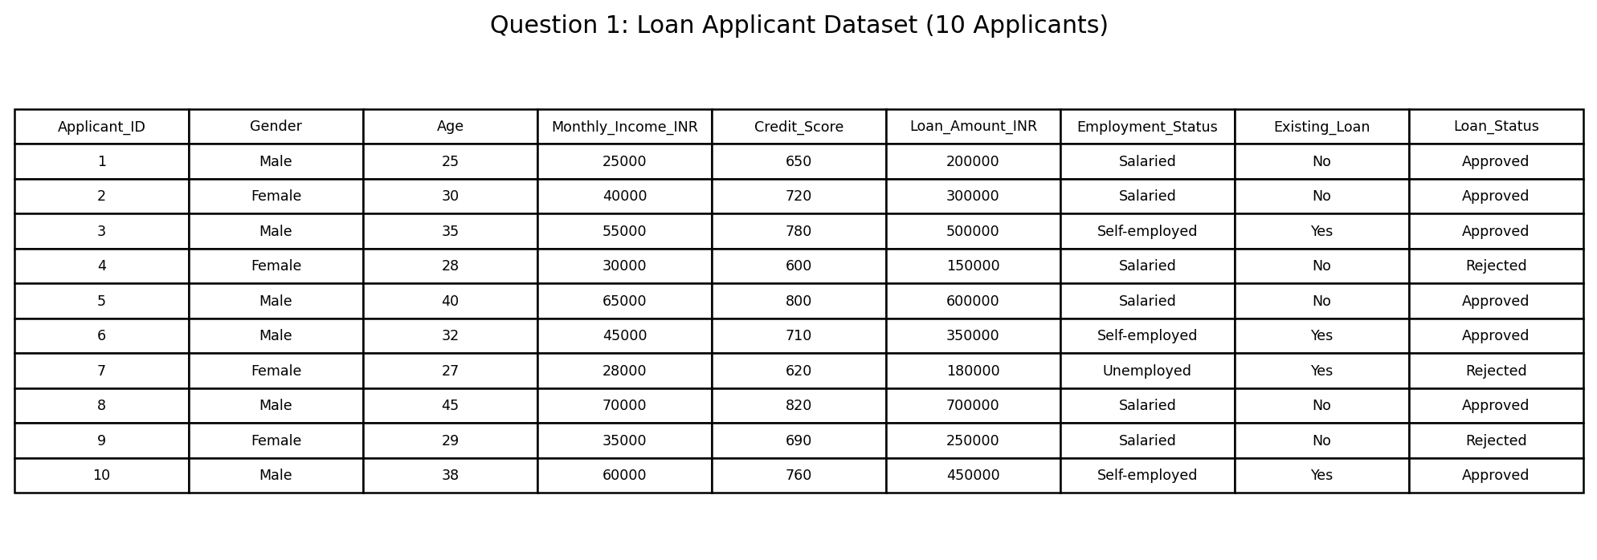

Question 2: Display Dataset Structure and Information
Formula: - $n=rows, p=columns$
Where:
$n=10,p=9$

$TotalElements=n×p=10×9=90$
Problem: Display the dataset and identify its structure, number of rows, and number of columns. .
Explanation: $n$ = Number of applicants (rows).
- $p$ = Number of attributes (columns).
- Total elements = $90$ data values, excluding column headings.
In R, print(data) displays the dataset, str(data) shows the data types, and dim(data) returns the number of rows and columns.
Code: -
print(data)
str(data)
dim(data)
barplot(data$Monthly_Income_INR,
names.arg = data$Applicant_ID,
main = "Monthly Income by Applicant",
xlab = "Applicant ID",
ylab = "Monthly Income (INR)",
col = ifelse(data$Loan_Status == "Approved",
"steelblue", "orange"))
legend("topleft",
legend = c("Approved", "Rejected"),
fill = c("steelblue", "orange"))
Expected output: The dataset records, data types, and dimensions.
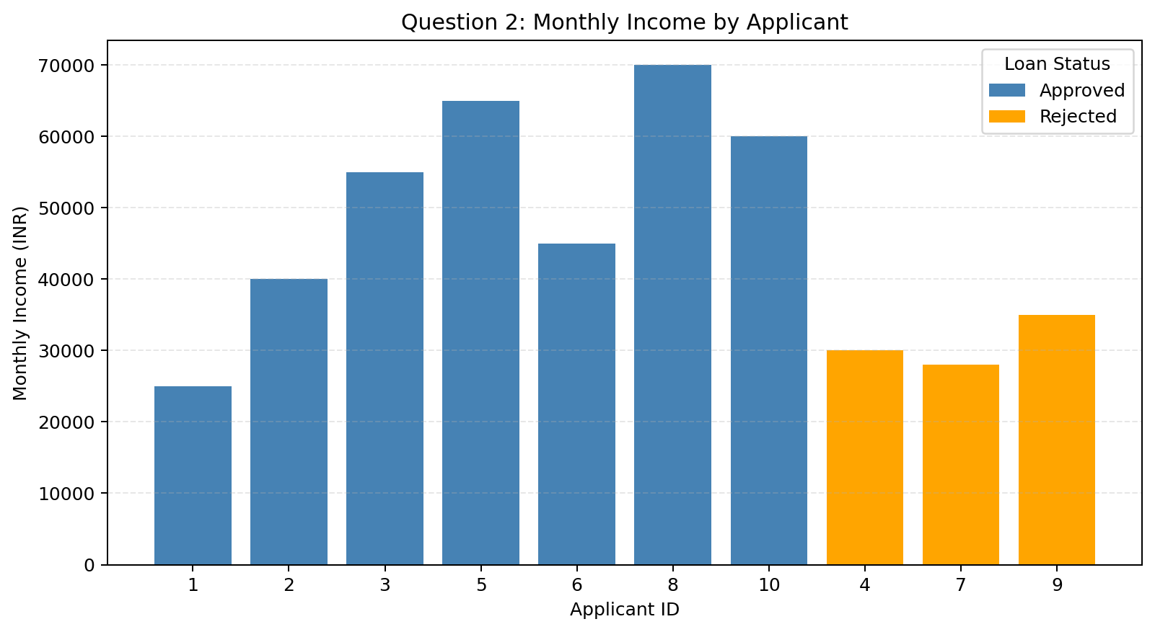

Question 3: Identify and Handle Missing Values
Formula: - $M_{j}=\sum_{i=1}^{n}{}I(x_{ij}ismissing)$
Here, $I$ equals 1 if a value is missing and 0 otherwise.
Formula for median imputation: -
For an odd number of sorted observations:

$Median=x_{\left(\frac{n+1}{2}\right)}$Identify missing values in the dataset and replace missing numerical values when necessary.
For an even number of sorted observations:

$Median=\frac{x_{(n/2)}+x_{(n/2+1)}}{2}$

Problem: Identify missing values in the dataset and replace missing numerical values when necessary.
Explanation: $M_{j}$ = Number of missing values in column $j$.
- $x_{ij}$ = Value in row $i$, column $j$.
- Median imputation replaces a missing numerical value with the column median.
For this dataset, if no values are missing, no replacement is required. In R, use colSums(is.na(data)) to count missing values.
CODE: -
missing_values <- colSums(is.na(data))
print(missing_values)
barplot(missing_values,
main = "Missing Values in Each Column",
xlab = "Attributes",
ylab = "Missing Value Count",
las = 2)
Expected output: A report of missing values and a dataset with the selected missing numerical values handled.
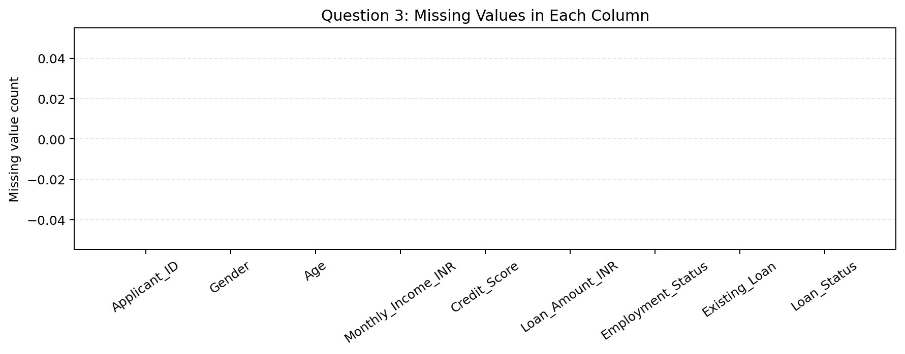

Question 4: Remove Duplicate Records and Convert Categorical Variables
Formula: - Dclean = Unique(D)

$N_{duplicates}=N_{original}-N_{unique}$
Example:
If the dataset contains 10 records but only 9 unique records:

$N_{duplicates}=10-9=1$

Problem: Remove duplicate applicant records and convert categorical columns into factors.
Explanation: $D_{clean}$ = Dataset after duplicate removal.
- $N_{original}$ = Original number of records.
- $N_{unique}$ = Number of unique records.
Categorical variables such as Gender, Employment Status, Existing Loan, and Loan Status can be converted into factors in R for statistical analysis.
CODE: -
data <- unique(data)
data$Gender<-as.factor(data$Gender)
data$Employment_{S}tatus<-as.factor(data$Employment_Status)
data$Existing_{L}oan<-as.factor(data$Existing_Loan)
data$Loan_{S}tatus<-as.factor(data$Loan_Status)
print(data)
print(table(data$Loan_Status))
barplot(table(data$Loan_Status),
main = "Loan Approval Status",
xlab = "Loan Status",
ylab = "Number of Applicants")
Expected output: A dataset without duplicate rows, with categorical columns converted to factors.
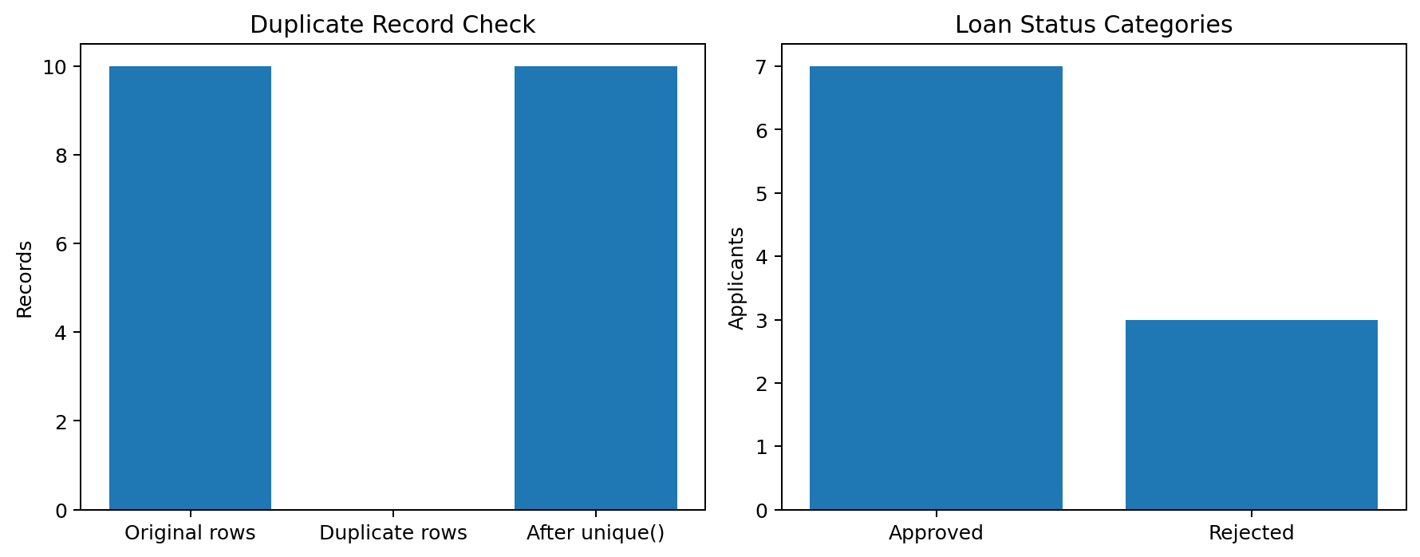

Question 5: Analyze and Save the Preprocessed Dataset
Formula for average monthly income: -
$\underline{MI}=\frac{\sum_{i=1}^{n}{}MI_{i}}{n}$
Using the sample dataset:
$\underline{MI}=\frac{453000}{10}=₹45,300$
Formula for average credit score:
$\underline{CS}=\frac{\sum_{i=1}^{n}{}CS_{i}}{n}$
$\underline{CS}=\frac{7150}{10}=715$
Using the sample dataset:

$\underline{MI}=\frac{453000}{10}=₹45,300$
Formula for average credit score:
$\underline{CS}=\frac{\sum_{i=1}^{n}{}CS_{i}}{n}$

$\underline{CS}=\frac{7150}{10}=715$
Applicant filtering condition:
$CS_{i}>700∧MI_{i}>₹40,000$
Problem: Calculate the average monthly income and credit score, then identify applicants whose credit score is greater than 700 and monthly income exceeds ₹40,000.
Explanation: $\underline{MI}$ = Average monthly income.
- $\underline{CS}$ = Average credit score.
- $E_{i}=1$ means the applicant meets both selected conditions.
- $E_{i}=0$ means the applicant does not meet both conditions.
These conditions are used for filtering and analysis; they are not a complete loan approval rule. Actual approval may also depend on employment, existing debt, loan amount, and lender requirements.
CODE: -
cat("Average Monthly Income:",
mean(data$Monthly_Income_INR), "\n")
cat("Average Credit Score:",
mean(data$Credit_Score), "\n")
eligible <- subset(data,
Credit_Score > 700 &
Monthly_Income_INR > 40000)
print(eligible)
write.csv(data, "Loan_Preprocessed.csv",
row.names = FALSE)
plot(data$Monthly_{I}ncome_{I}NR,data$Credit_Score,
main = "Loan Applicant Eligibility",
xlab = "Monthly Income (INR)",
ylab = "Credit Score",
pch = 19,
col = ifelse(data$Credit_Score > 700 &
data$Monthly_Income_INR > 40000,
"green", "gray"))
abline(v = 40000, lty = 2)
abline(h = 700, lty = 2)
Expected output:
- Average monthly income and credit score.
- A list of applicants meeting both conditions.
- A cleaned CSV file named Loan_Preprocessed.csv.
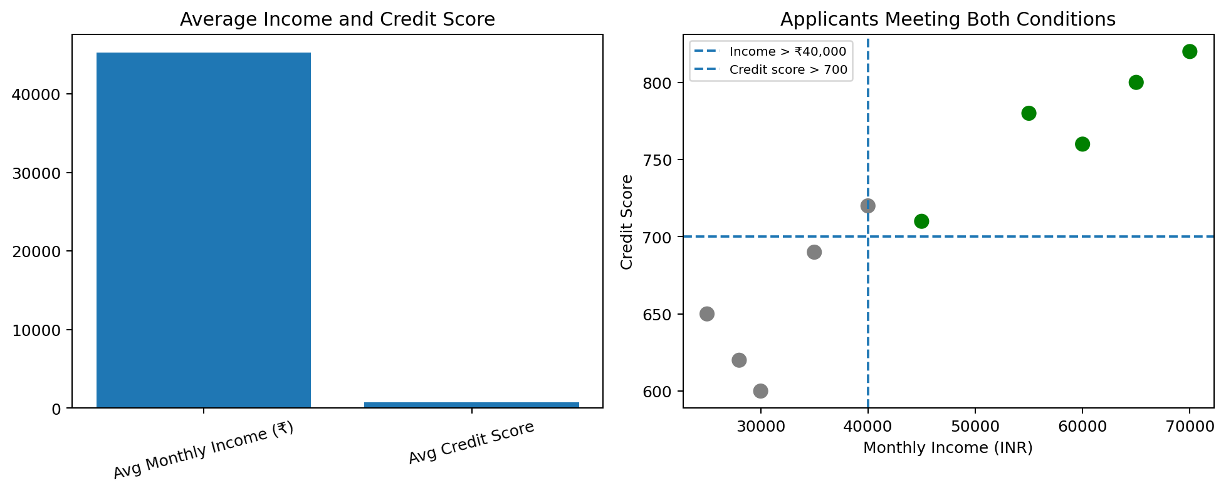

Annexure

Assignment 2

Code of Conduct:

I M. Jaya prakash Narayana Reddy(192425268)(Name / Reg No) certify that this submission is my original work and that I have adhered to the guidelines specified for this assessment.
I understand that any violation of academic integrity rules will result in disciplinary action.

Signature of the student: jayaprakash

